The code maps a potentiometer reading on pin in on A0 and outputs a pwm signal that you can vary on pin 3. The red leads at the top of the breadboards were used for the oscilloscope probe grounds. One wire needs to be grounded to the same ground as the EVM voltage input (+VM).

**PWM Table**

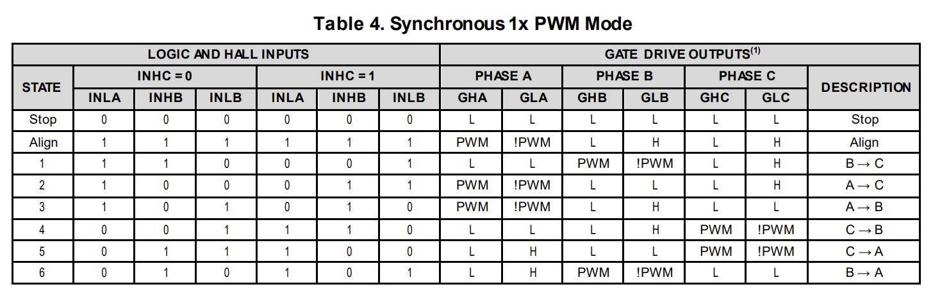

This is the logic table. When it says PWM that will map the PWM input signal you give it on INHA. iPWM is the inverse. The output PWM Wave will have the same frequency and duty cycle as the input PWM wave.

I tested several combinations and was able to map this table out.

*Signal Mappings*

| DRV Signal | Connection for 1x PWM | Motor wire color |
| --- | --- | --- |
| INLA | HALL_A | Blue |
| INHB | HALL_B | Orange |
| INLB | HALL_C | Brown |
| INHC | Direction |  |
| INHA | PWM |  |
| INLC | !Brake (active low brake) |  |

**IMPORTANT**

* Enable pin must be set high
* INLC must be set high
  + This pin sets the brake, making every GHX High.
  + By default it is low which enables the break
* Right now we can “hard code” the logic values on this table for testing and debugging. In the future we can connect these to the hall sensor outputs directly from the motor. The 1x PWM section in the drv datasheet discusses this further.

**Diagrams for the Left and Right set of Pins on the EVM**

